Name: ________________________________________ Block: ____________________ Date: ________________

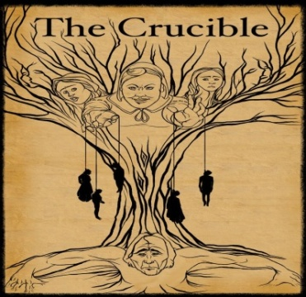
The Crucible WebQuest

ASSIGNMENT:
Use the following links to gain background information pertaining to The Crucible. Once you
have thoroughly researched and answered the questions, predict why Arthur Miller chose
the Salem Witch Trials as the basis of his play. An electronic version of this webquest is
available at MissKMuller.Weebly.com EN2CP RESOURCES THE CRUCIBLE/WEBQUEST

COMMUNISM
- Visit: http://study.com/academy/lesson/communism-definition-examples.html
- Watch the video for clarification (No need to subscribe—the first half is useful enough)
- Define communism and explain why you would/would not want to live in a communist society.
Definition of communism: | Would you want to live in a communist society? Why/why not
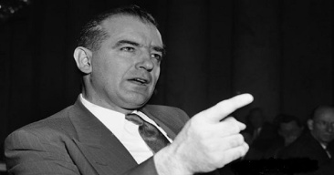
MCCARTHYISM
- Visit: https://www.britannica.com/topic/McCarthyism
- In the box below, describe Joseph McCarthy’s role in government and his most
well-known claim. Then, define the term McCarthyism.
Describe McCarthy’s role in government/most well-known claim. | Definition of McCarthyism  Visit: http://www.dictionary.com/browse/mccarthyism
- Examine the political cartoon and then explain how it illustrates the concepts of McCarthyism.
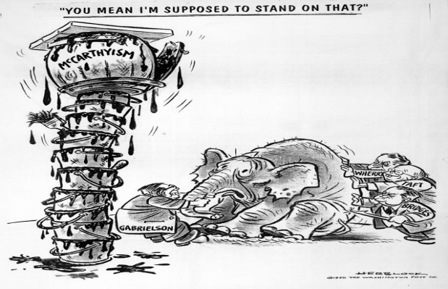
SALEM WITCH TRIALS
- Visit: http://historyofmassachusetts.org/the-salem-witch-trials/
- Fill in the blank: “In Massachusetts during the 17th century, people often feared that the ___________________ was constantly trying to find ways to infiltrate and destroy Christians and their communities”
- Define the terms “mass hysteria” and “scapegoat.” Next, provide a modern example/personal experience.
Definition of mass hysteria  Visit: http://www.dictionary.com/browse/mass-hysteria | Definition of scapegoat  Visit: http://www.dictionary.com/browse/scapegoat
Can you think of a movie/TV show/book that includes an example of mass hysteria?
Do you have a personal experience that connects to either of these terms? Please share your responses below.
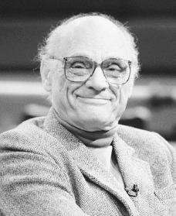
ARTHUR MILLER
- Visit: http://www.pbs.org/wnet/americanmasters/arthur-miller-elia-kazan-and-the-blacklist-
none-without-sin-why-arthur-miller-wrote-the-crucible/5911/
- Watch the video for clarification.
- How are the Salem Witch Trials of 1692 similar to McCarthyism/The Red Scare of 1950s?
Why do you think Arthur Miller chose the Salem Witch Trials as the basis to his play,
The Crucible? Record your response in the box below.

