How to Make a TurnItIn Account

- Google TurnItIn.com
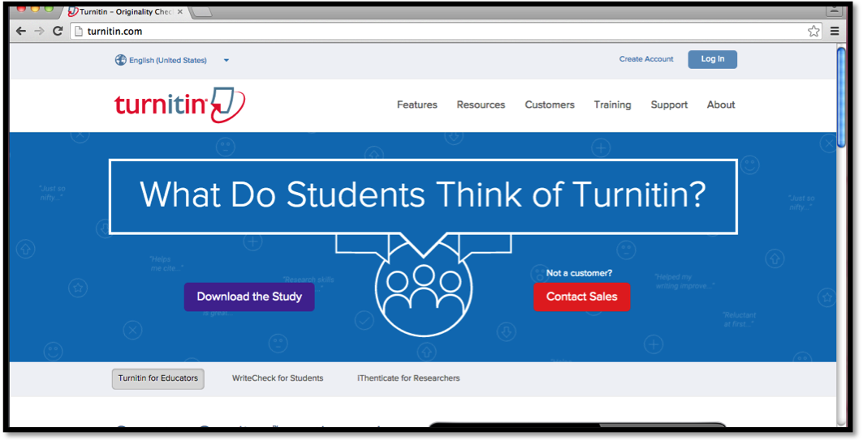
- Click the “Create Account” link at the top right-hand side of the screen
- Near the bottom of the grey box, click on the “Student” link

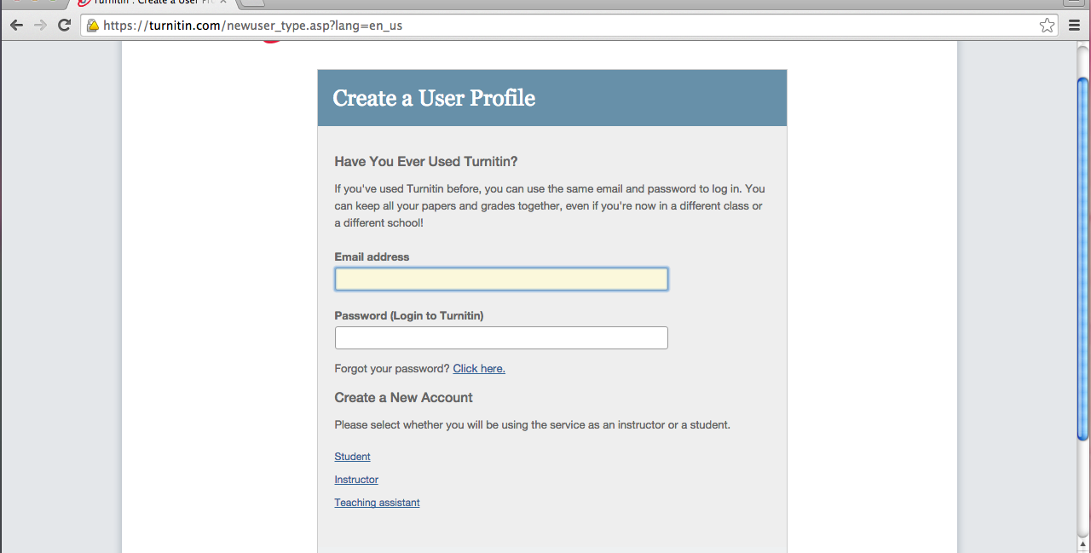
- My class ID is: _______________________
- My class enrollment password is: _______________________
- Enter the following information
  - SUGGESTION: Save your email and password in the notes section of your phone and/or type them in a Word document and save the document to your H-Drive for safe keeping—you will need to use your TurnItIn account for each writing assignment

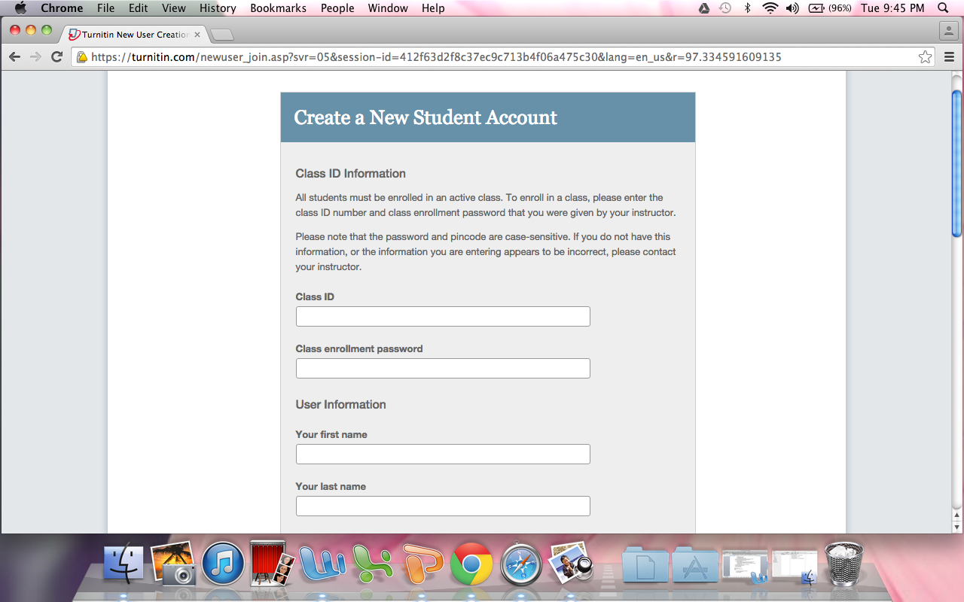

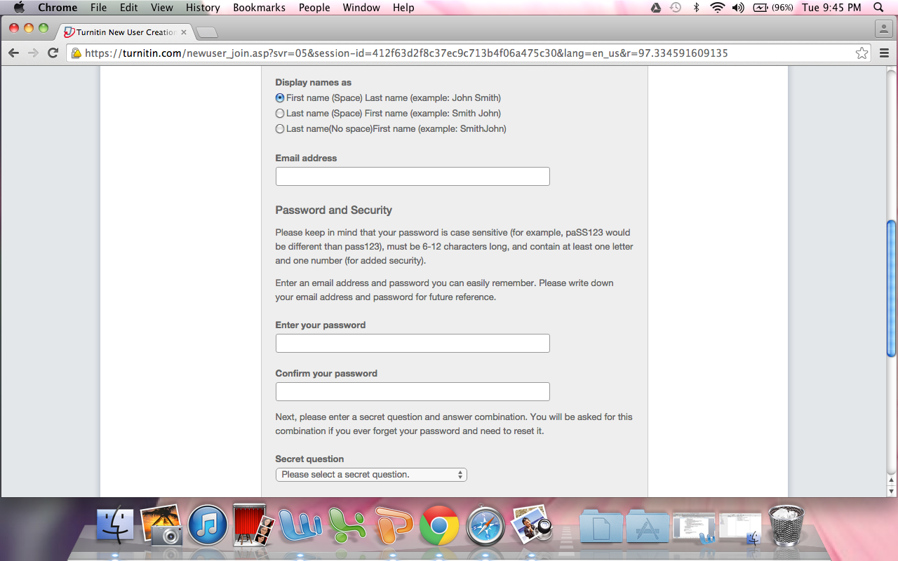

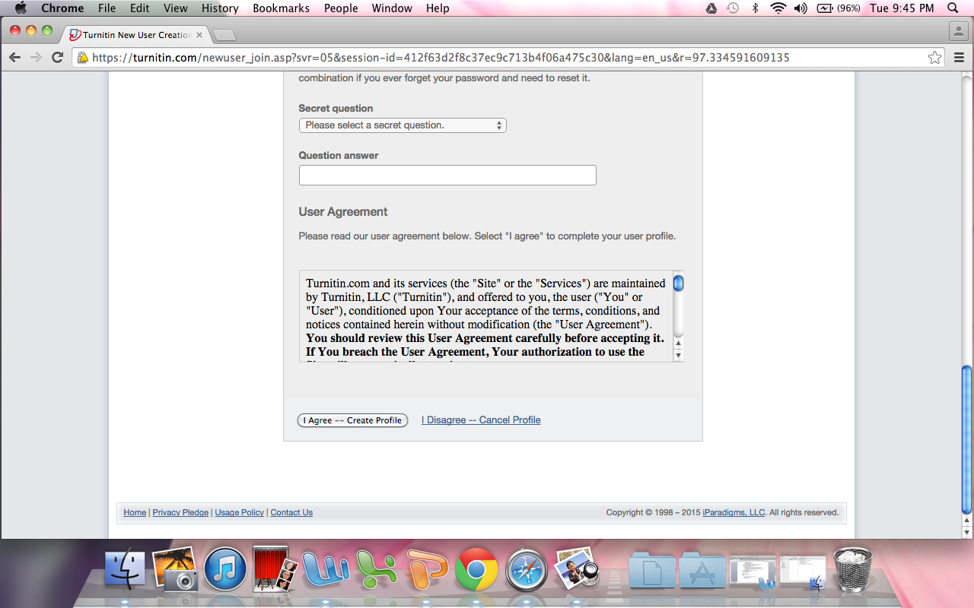

- Click on the class you need to submit an assignment to

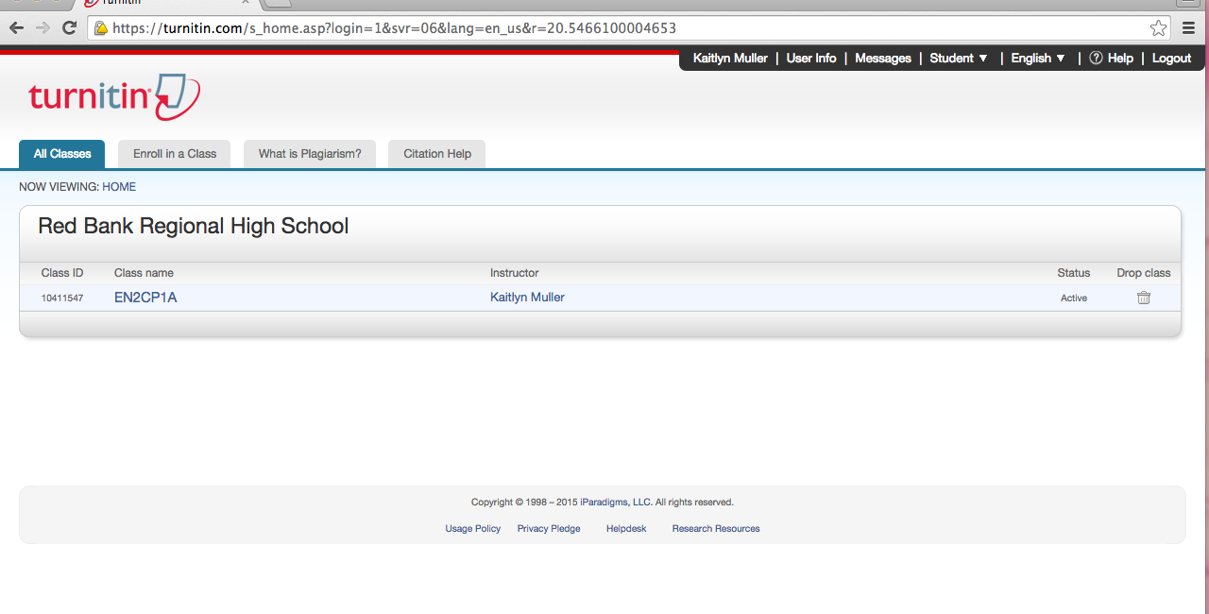

8. Click the blue “Submit” button to upload your assignment



