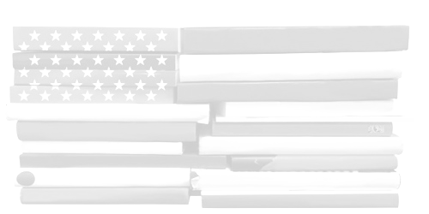
English II CP
Miss Muller
2016-2017

Email: Kmuller@rbrhs.org
Website: http://misskmuller.weebly.com

Course Overview:
- According to RBR’s guidelines, English II CP is “a challenging course which covers American literature from the Puritans to the present. We study short stories, the novel, non-fiction, drama, and poetry …. Grammar, writing, and vocabulary work are ongoing throughout the year.”

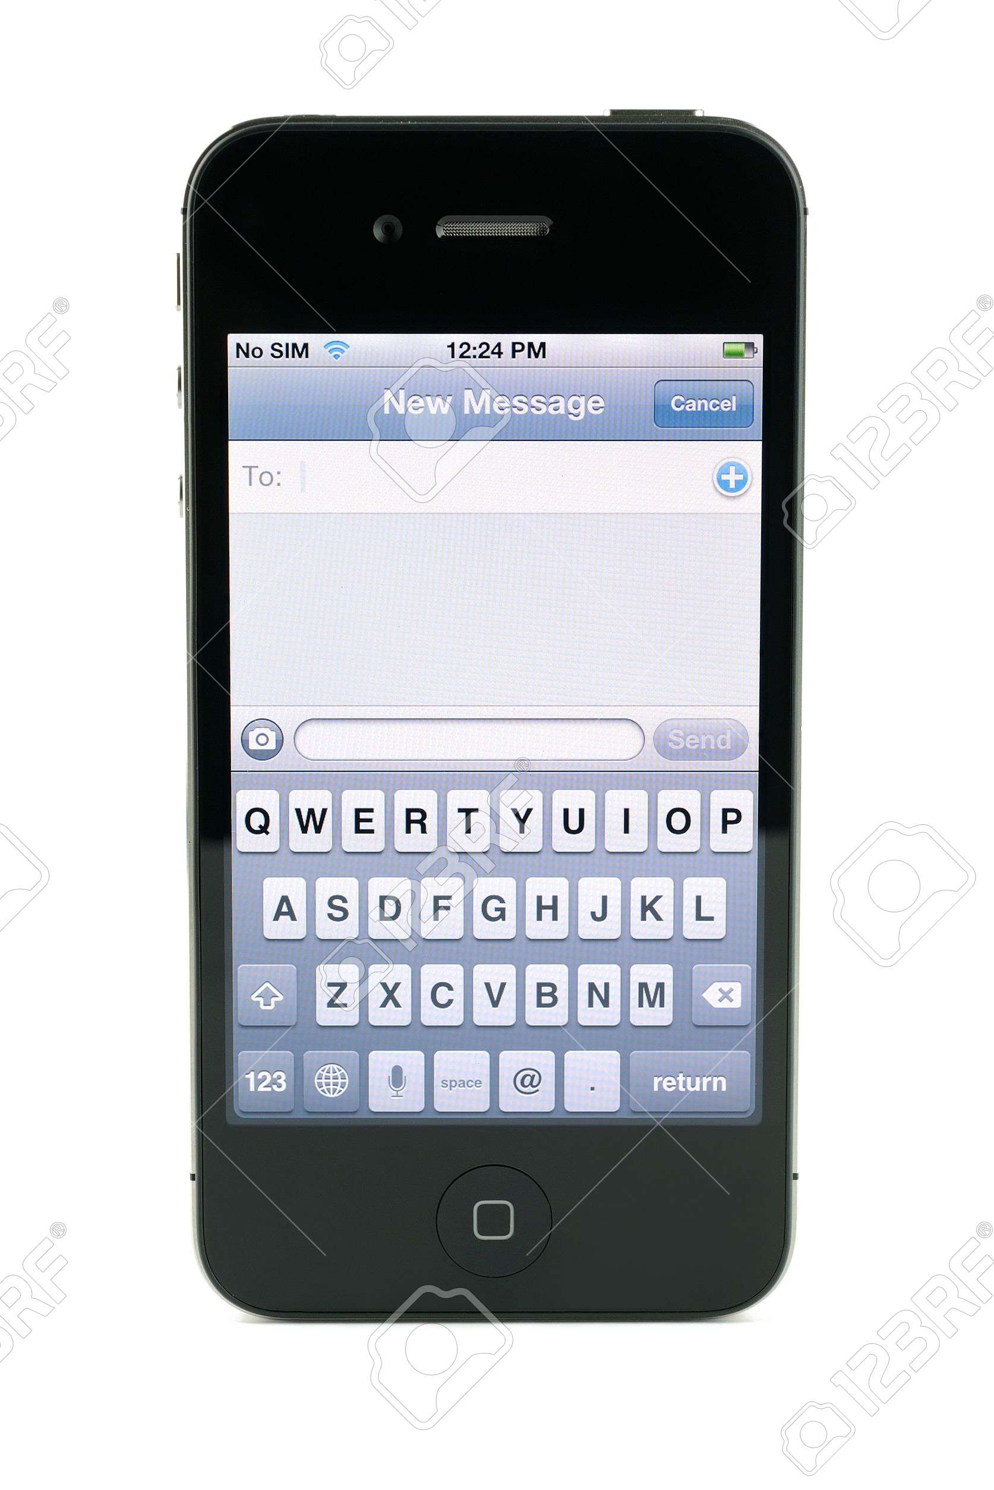
What You’ll Need to Check Before Class:
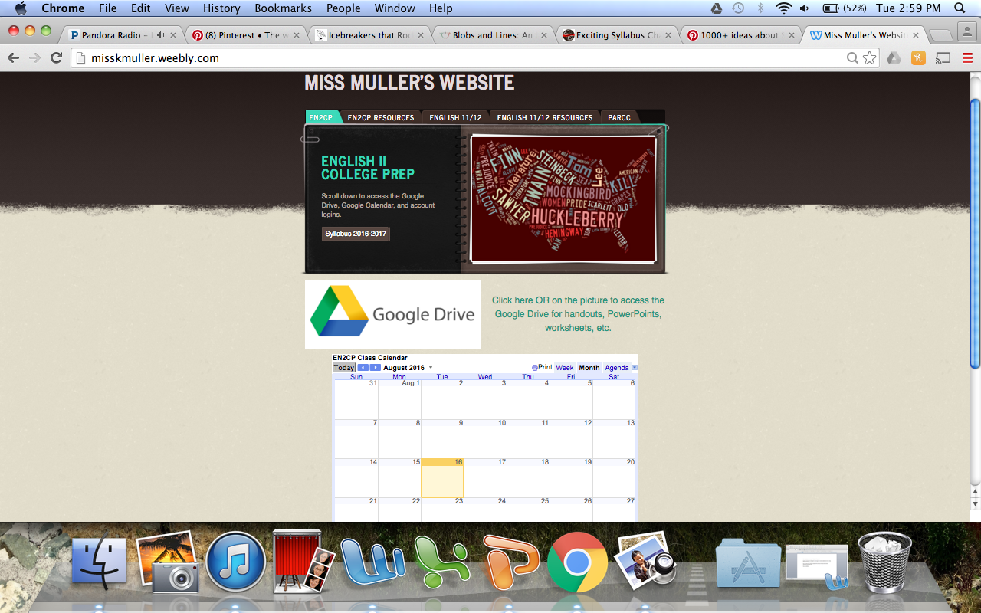
Enter class number

Enter class code

MissKMuller.Weebly.com  On this website, you will find: worksheets, handouts, PowerPoint Presentations, homework  assignments, links to extra resources, e-books,  articles, login information, and more.  This website is updated on a regular basis, so take advantage of this resource and check it frequently. | Remind Messaging App  Remind is a messaging system that allows teachers to send text messages or emails without needing individual phone numbers or email addresses. Messages regarding homework assignments, due dates, class materials, etc. will be sent regularly using the Remind App.


Class Materials:
- A three-ring binder and homework folder will be provided and must be used
just for English materials. This binder will be kept in the classroom for safekeeping.
Always keep your binder organized—you never know when a binder check will be!

Grading Policy:
Grading Breakdown Example:
Points Earned | 520 | 87 Average
Possible Points | 600 | 87 Average
- Grades are based on a point system. Assignments
will be labeled with a “maximum point value” that
you will be able to achieve. At the end of each marking period, all of the points you have earned are added together and divided by the total possible points for the term.

Class Participation Tickets:
- As an incentive to promote class discussion and participation students have the opportunity to earn “class participation tickets” whenever they volunteer to read, ask a question, share a thought, etc. Once a ticket is received, the student writes his/her on the back. At the end of class, the tickets are collected and one ticket is drawn at random. Whichever student’s ticket is chosen earns two points extra credit for the day. The more you participate, the higher your chances are to earn extra credit.
What We’ll Read:
- Writings from Early America: The Puritans
  - Anne Bradstreet, Jonathan Edwards, and William Bradford
- Arthur Miller’s The Crucible
- Writings from the Revolutionary Period
  - Ben Franklin, Patrick Henry, and others
- The “Isms” of the Early to Mid-1800s: Romanticism, Transcendentalism
  - Washington Irving, Edgar Allen Poe, Henry David Thoreau, etc.
- Mid to Late-1800s
  - Emily Dickenson, Walt Whitman
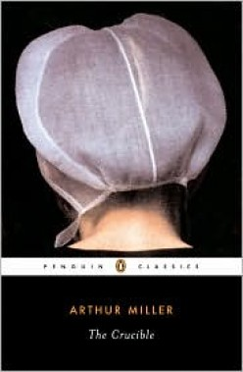

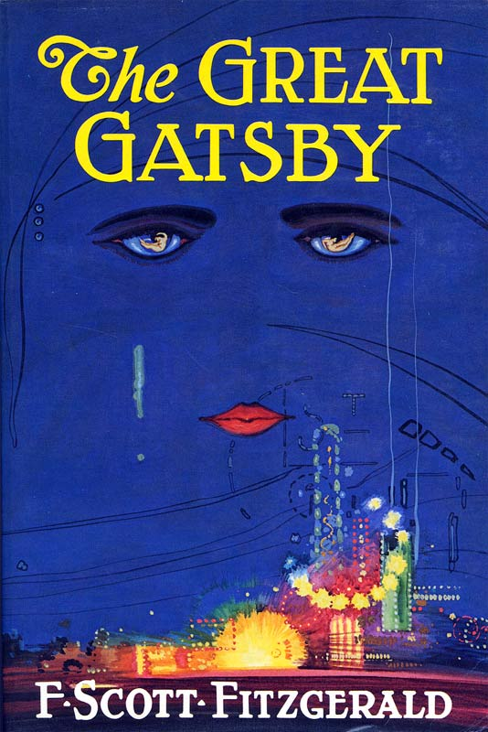
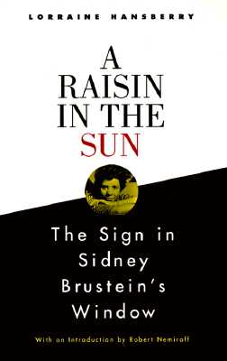
- J. California Cooper’s Family
- Some More “Isms” … Realism and Naturalism
  - Mark Twain, Jack London
- F. Scott Fitzgerald’s The Great Gatsby
- Modern American Short Stories
  - William Faulkner, John Steinbeck, Flannery O’Connor, and others
- The Harlem Renaissance and Lorraine Hansberry’s A Raisin in the Sun

Extra Help:
- I stay after school at least one day a week for Homework Help in the Media Center.
If I am not available the day you plan to stay after, don’t worry--there will always be another English teacher after school Tues-Thurs.

- Miss Muller’s Study Hall: _________________________

Classroom Expectations:
- Be on Time, Be Prepared, and Be Attentive.

- Be Respectful. One of my goals is to create a welcoming, supportive, and fun classroom environment. In order to achieve this goal, all students must demonstrate respect for themselves, their peers, and authority figures.

- Absences/Make Up Work. If you are absent, it is your responsibility to check my website and/or contact/meet with me on the alternating schedule day. You are expected to be up to date with homework assignments and ready for Reading Check Quizzes the day you return to class.

- Late Work Policy. If you forget to do an assignment, you may hand it in the following class block for partial credit. This means, if you have English on an A day, you have the opportunity to hand in your late assignment the following A day to earn partial credit.

- Late Paper Submission Policy. Submitting a paper after the due date will result in a ten-point deduction for every day it is late. This means, if you have English on an A day and you do not submit your paper until the following A day, you will receive a twenty-point deduction.

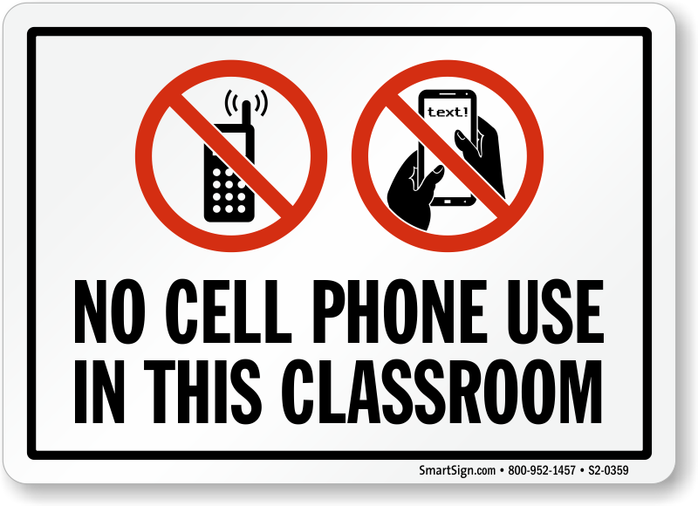
- Please, No Cell Phones. All of RBR’s school rules apply in this classroom.
First offense: warning. Second offense: write up. There will be times throughout
the school year where I will allow you to use your phones in class for certain
activities, but other than those specified times, do yourself a favor and put your
phone on silent and keep it in your bag.

I believe in give-and-take. If you act mature and do your best, I will reward you by making this class as fun and interesting as I can, as well as giving you choices. On the other hand, act like freshmen, and I’ll treat you accordingly.
I have read and understand the expectations of English II CP:

Your Signature | Date | Parent/Guardian Signature | Date

